KJSCE/IT/LYBTech/SEMVII/STQA/2019-20



**Experiment No. 1**

**Title: Mini Project on testing Web application/Mobile application**

KJSCE/IT/LYBTech/SEMVII/STQA/2019-20

**Batch: A3 Roll No.: 1614040** **Experiment No.:1**

**Aim:** To develop a Web application/Mobile application and test it by using any open sourcesoftware testing tool.

___________________________________________________________________________

**Resources needed:** Internet, Open source testing tool, Application development software



**Theory:**

In [software testing,](https://en.wikipedia.org/wiki/Software_testing) test automation is the use of special [software](https://en.wikipedia.org/wiki/Software) (separate from the software being tested) to control the execution of tests and the comparison of actual outcomes with predicted outcomes. Test automation can automate some repetitive but necessary tasks in a formalized testing process already in place, or add additional testing that would be difficult to perform manually.

Some [software testing](https://en.wikipedia.org/wiki/Software_testing) tasks, such as extensive low-level interface [regression testing,](https://en.wikipedia.org/wiki/Regression_testing) can be laborious and time consuming to do manually. In addition, a manual approach might not always be effective in finding certain classes of defects. Test automation offers a possibility to perform these types of testing effectively. Once automated tests have been developed, they can be run quickly and repeatedly. Many times, this can be a cost-effective method for regression testing of software products that have a long maintenance life. Even minor patches over the lifetime of the application can cause existing features to break which were working at an earlier point in time.



**___________________________________________________________________________**

**Activities:**

1. Develop a sample web/mobile application.
2. Explore open source software testing tools for testing web/mobile applications.
3. Document the functionality of testing tool with its features.
4. Document sample application features.
5. Create test cases and test scripts.(Any one testing tool)
6. Run and document test cases.

**___________________________________________________________________________**

**Results: (Document printout as per the format)**

**1) Developed a web application**

**URL :** <http://intersign.atwebpages.com/>

**Domain : Interior Design**

**Problem Definition :**

The interior design industry is ever-growing. New homeowners are turning to interior designers, now more than ever. Decades ago, an interior designer was accessible only by the rich. The remaining population enjoyed well-decorated homes only through magazines and catalogs. However, over the years, there has been a wide-spread growth of services and consumption, making interior designing a necessity rather than a luxury. Despite this growth, there a few problems that still afflict the interior decoration industry and its high time that all stakeholders come together to resolve them.

Intersign's goal is to create a unique and innovative solution that will be a perfect balance between functionality and aesthetics. We emphasize on budget management and systematic scheduling of all activities to ensure the smooth and successful completion of all interior design projects exceeding the client’s expectations.

Traditional interior designing activities have been automized with the help of intersign interior design website. Through this website, the credibility of our interior designing services can be verified. Our designs can be seen by the user and have appropriate expectations. Our clients can contact us for booking our services.

**Technology Used:**

* Frontend : HTML5 , CSS3 , JavaScript , jQuery ,Bootstrap, Ajax
* Server Side Scripting: PHP, JSON
* Database : PhpMyAdmin MySQL
* Server: Xampp





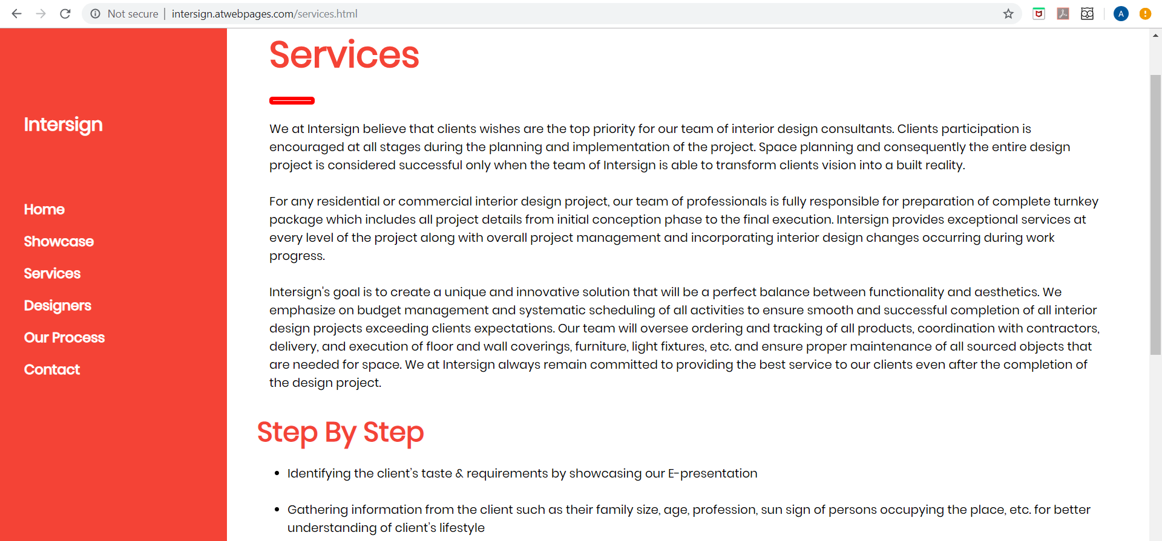

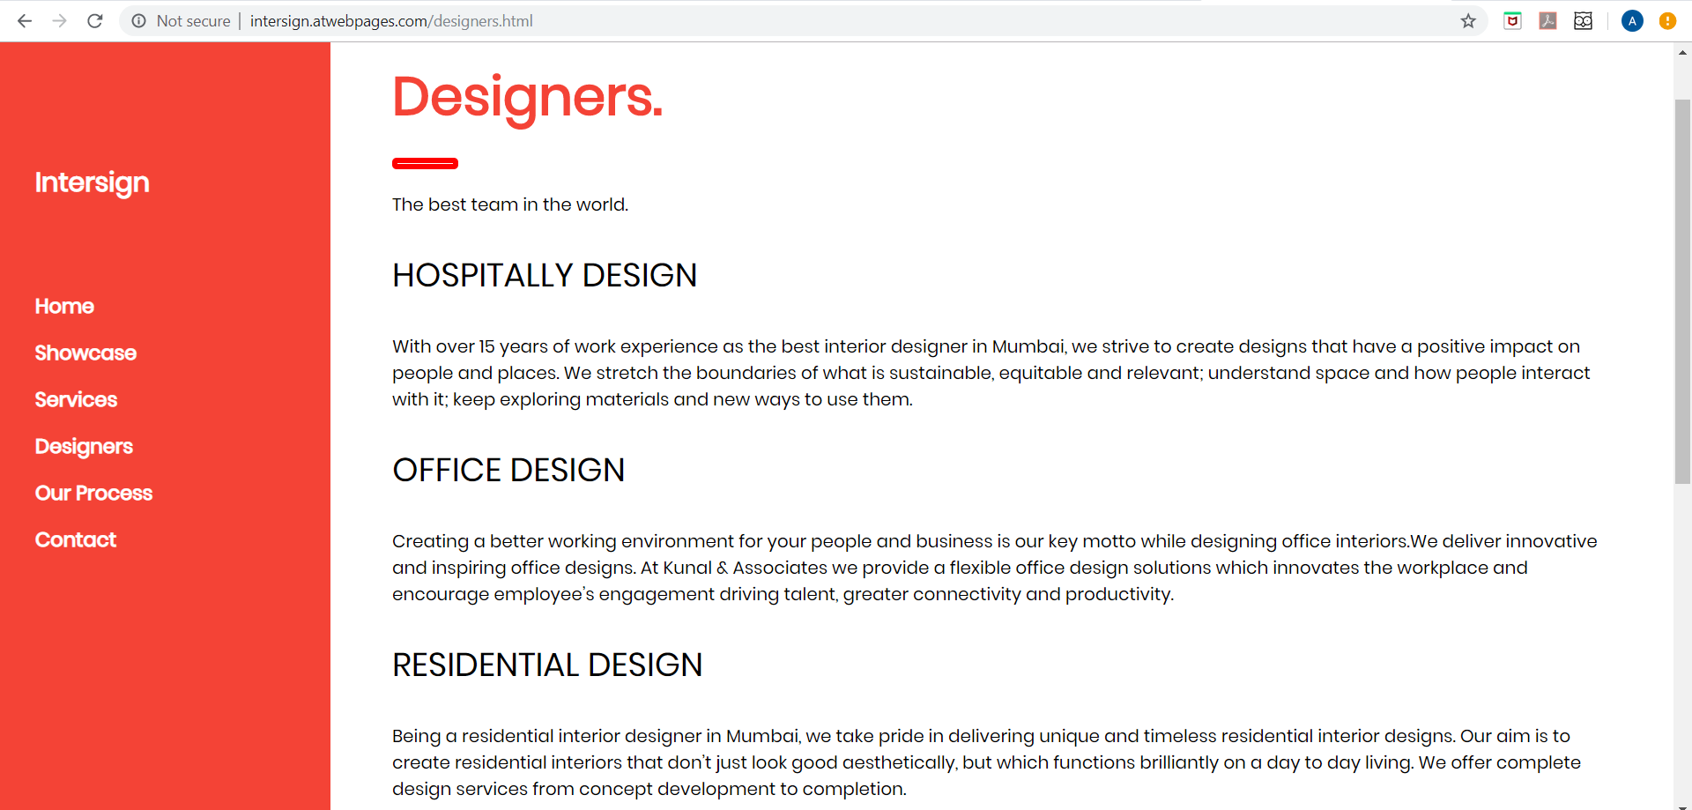

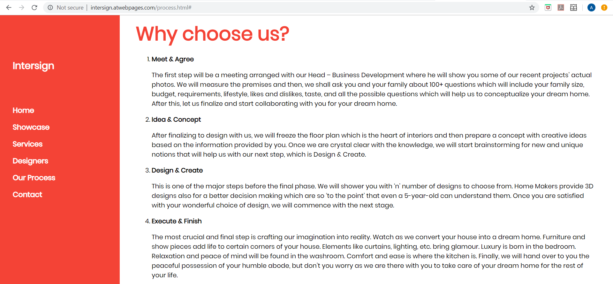

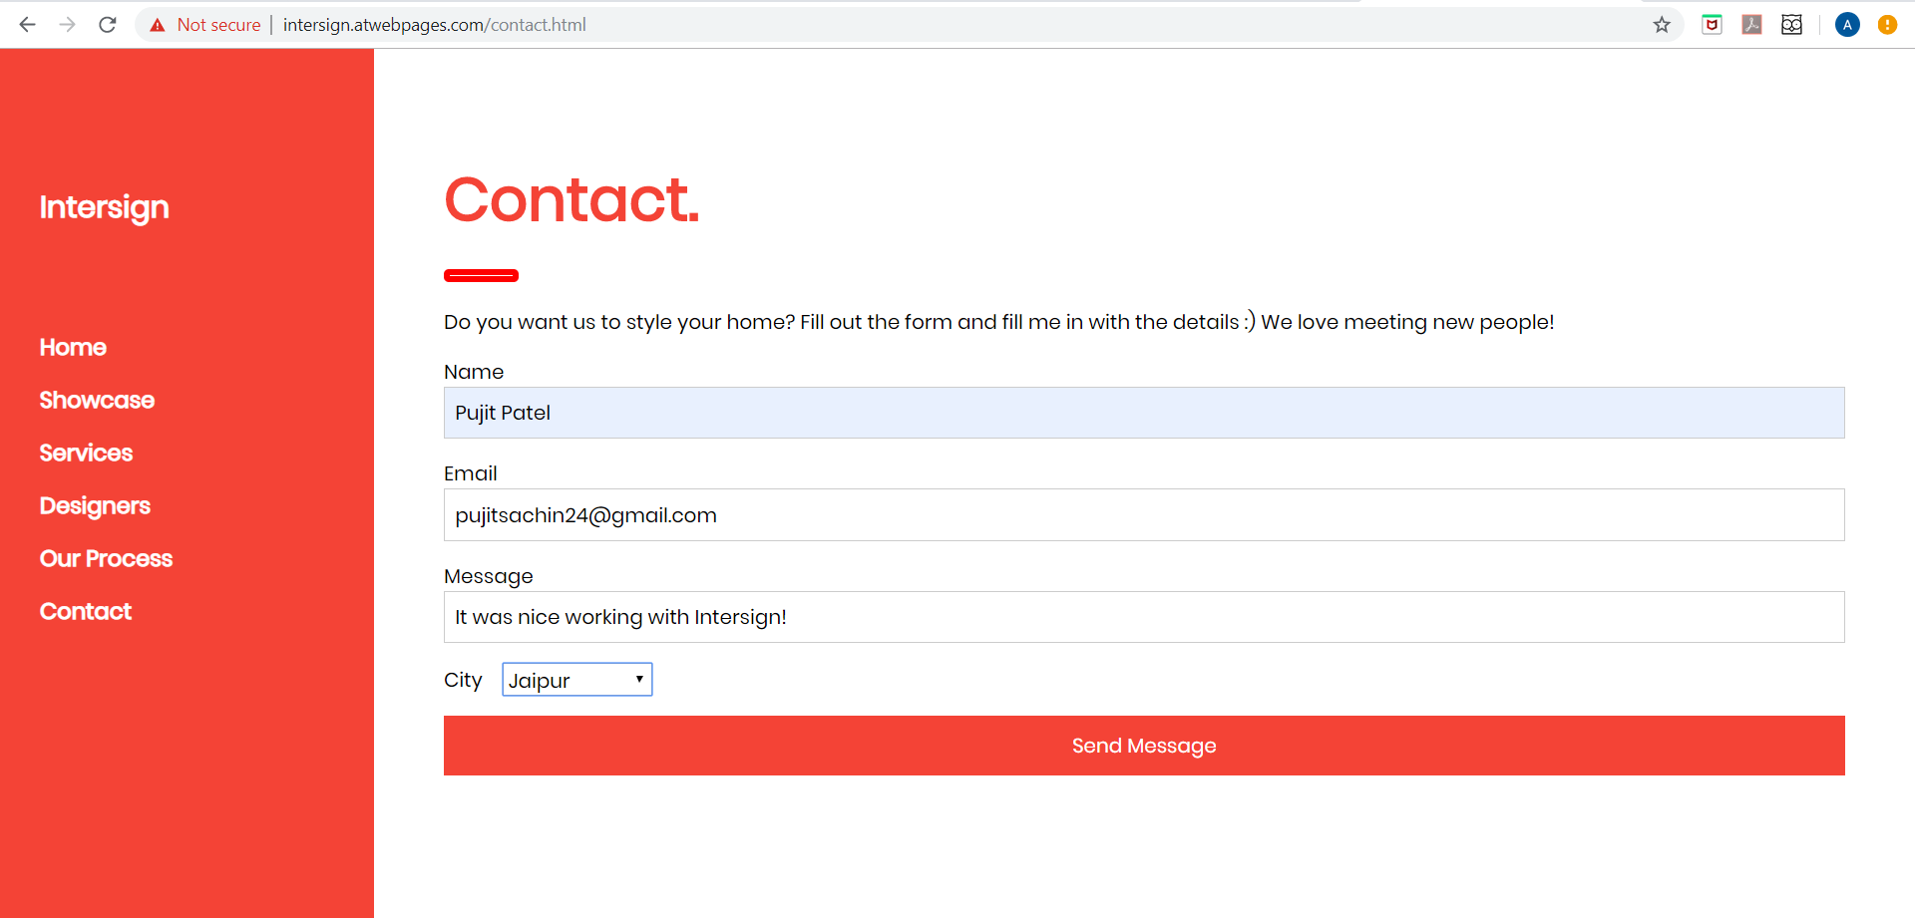

**2) Explore open source software testing tools for testing web/mobile applications**

**1. Testing Tools and Methods Used** :

1. **W3C Validation tool** - HTML /CS validation tool
2. **GTmetrics** – Web page performance tool
3. **Dotcom tool** – Website speed testing tool
4. **Sitechecker** – Eavaluation of page score
5. **Dareboost**  – Website performance tool
6. **checkMyColour** – UI testing tool (particularly colour combination)

**2. Explanation Of Each Tool Used :**

**1) W3validator :**

The Markup Validation Service is a validator by the World Wide Web Consortium (W3C) that allows Internet users to check HTML and XHTML documents for well-formed markup. Markup validation is an important step towards ensuring the technical quality of web pages. However, it is not a complete measure of web standards conformance.

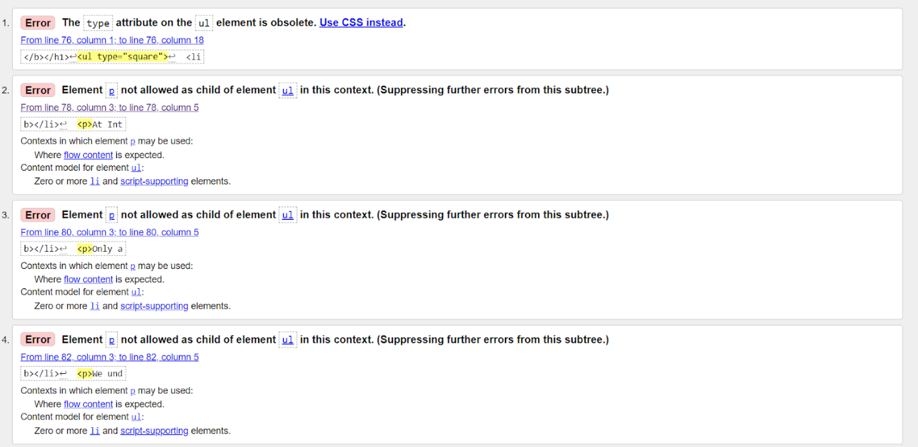

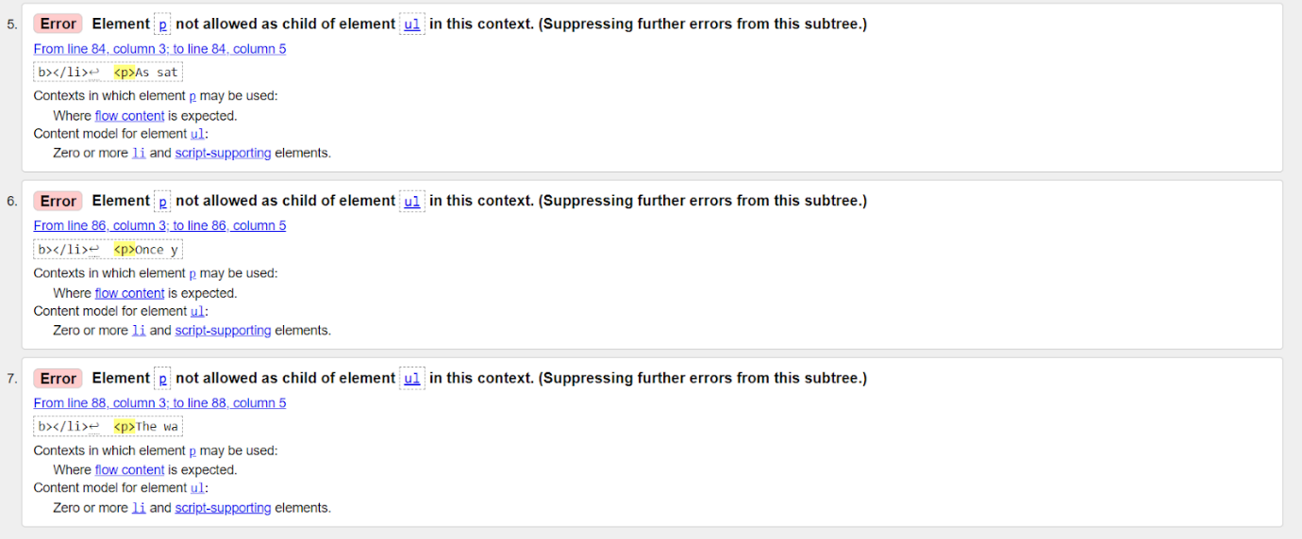

**2) GTmetrix :**

GTmetric helps you develop a faster, more efficient, and all-around improved website experience for your users. We use Google PageSpeed and Yahoo! YSlow to grade your site's performance and provide actionable recommendations to fix these issues. GTmetrix's Report Page neatly summarizes your page performance based off key indicators of page load speed.

1. Analyze your page with Google PageSpeed and Yahoo! YSlow rulesets
2. Get your page's Page Load Time, Total Page Size and Total # of Requests
3. See your page's performance relative to the average of all sites analyzed on GTmetrix
4. Executive: Overall score information and Priority Issues
5. History: Graphed history of past performance
6. Waterfall: Graph of your site's loading timeline
7. Technical: In-depth PageSpeed & YSlow information

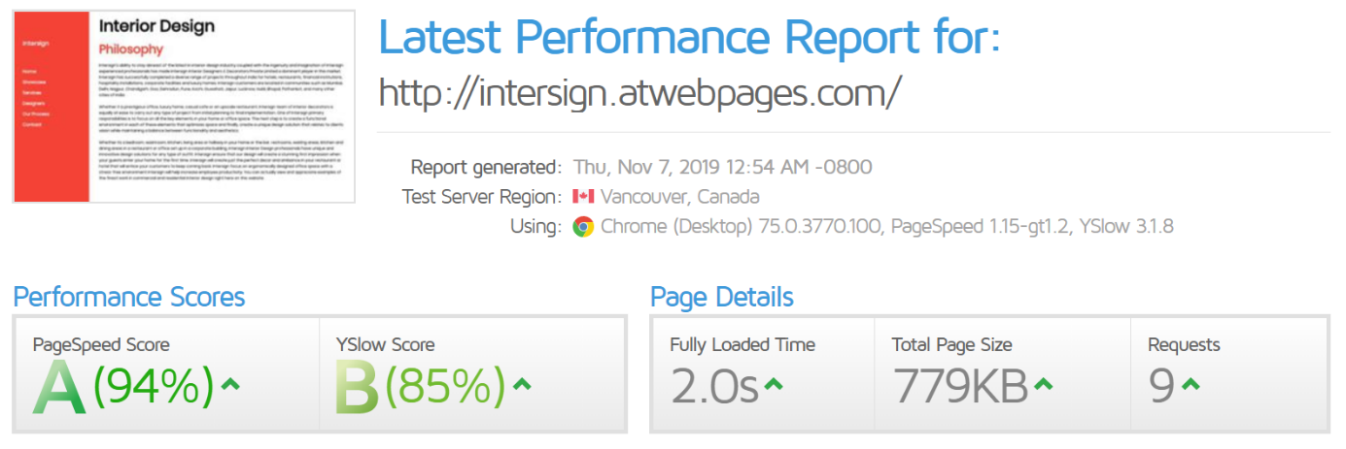

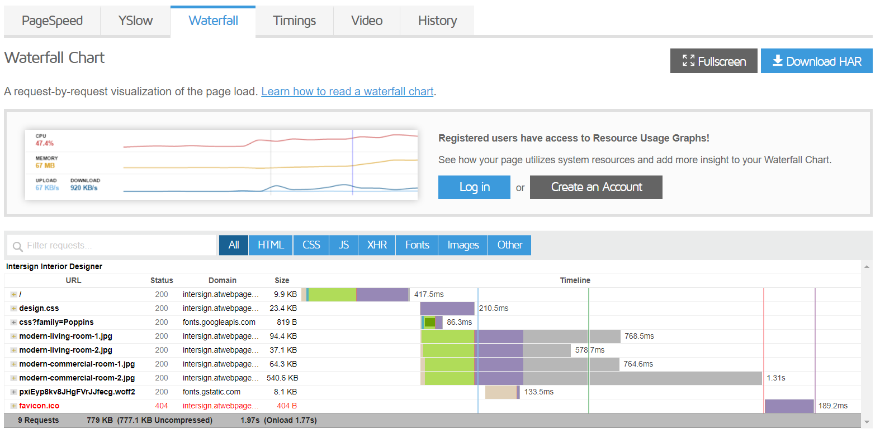

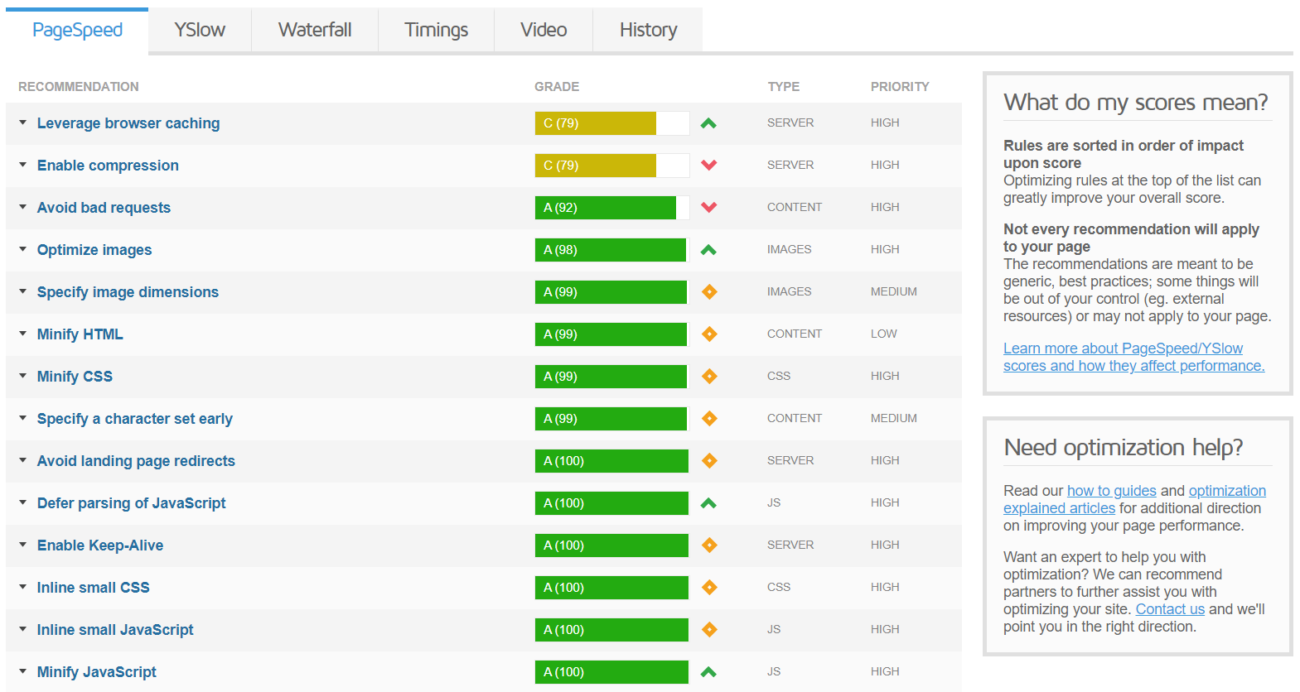

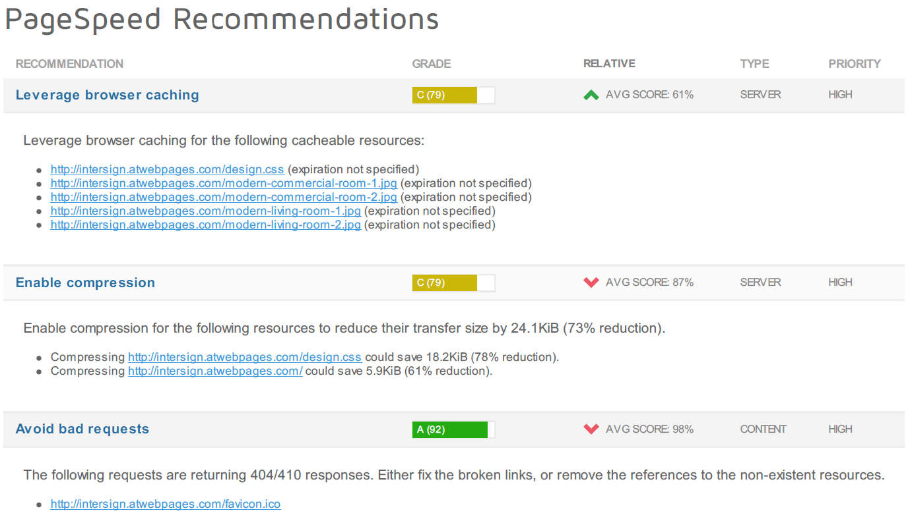

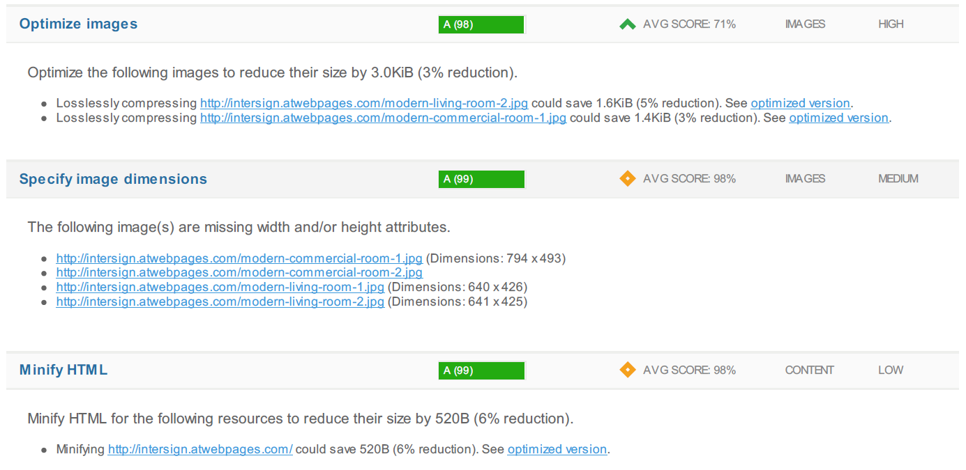

**3) Dotcom-tools:**

Dotcom-Monitor's website speed test enables users to test their website from 20 locations worldwide, including cloud based tests (Amazon-US-East) and from behind the Great Firewall of China (Shanghai, China). Once a test is complete, users can select "details", drilling into robust performance reports and waterfall chart analysis. Users may also select which browser they'd like to test from. This test supports Chrome, Firefox, IE & mobile browsers including iPhone, iPad and more! Dotcom-Monitor is continually developing performance tools to help users, webmasters, and developers improve their sites and their experience on the web.

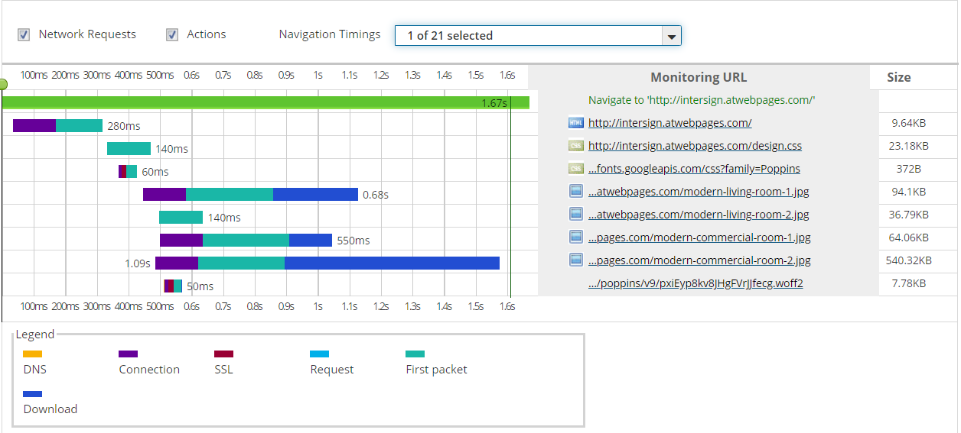

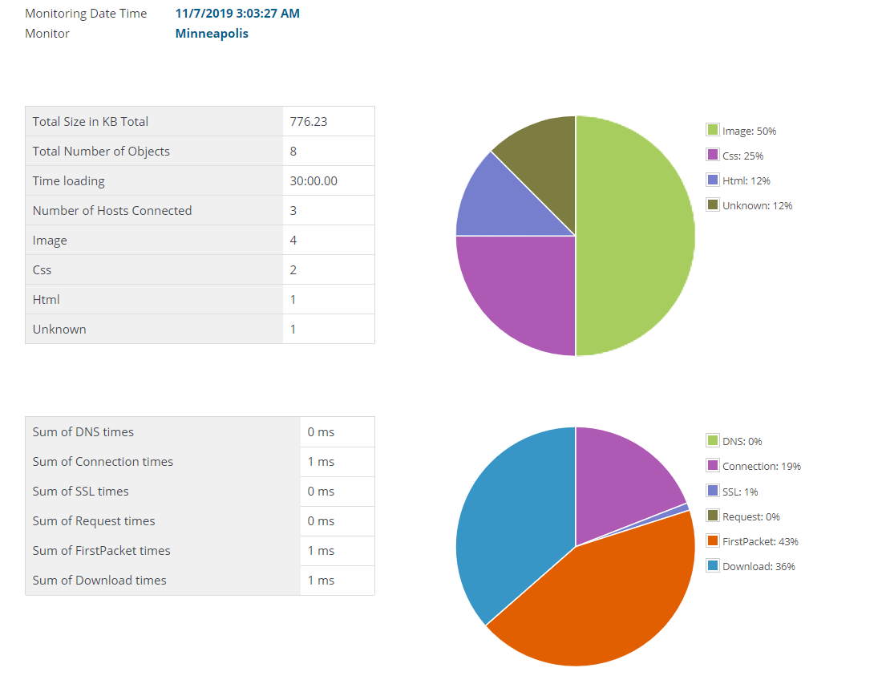

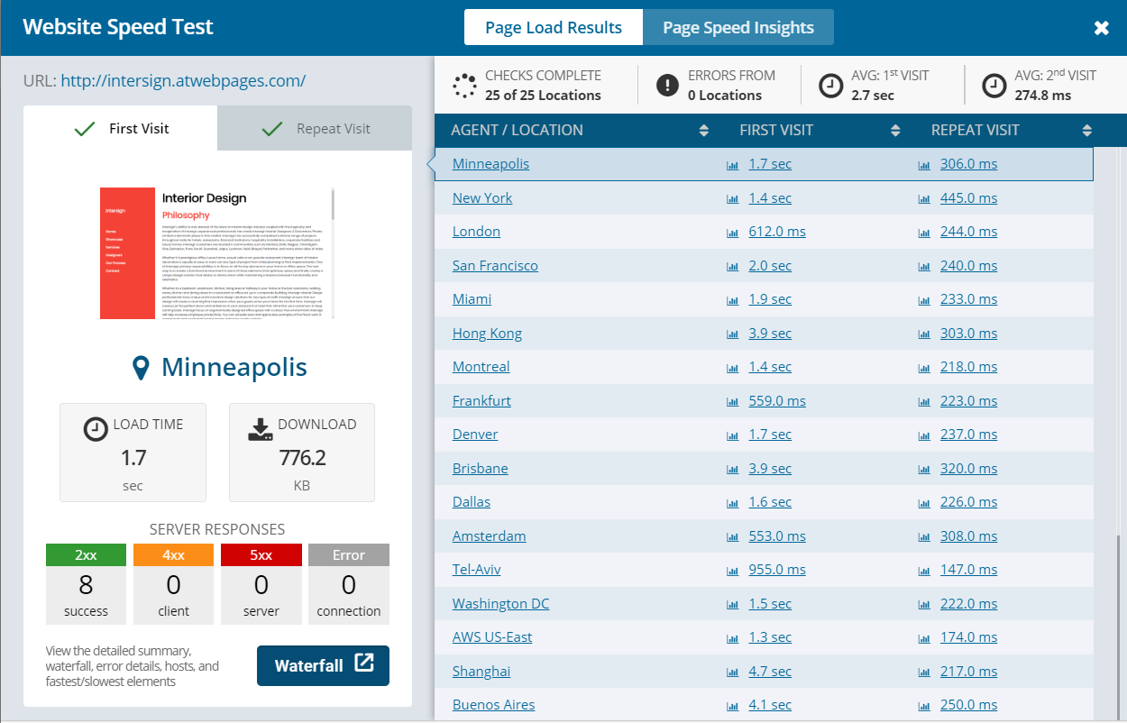

**4) Dareboost :**

Dareboost provides an installation-free, single-click service to test the speed of any given web page. More advanced than a regular bot, our Real Browser Testing service (based on Google Chrome) allows you to run highly configurable and realistic tests reproducing the exact same conditions as your real-life users.

From screen resolution to bandwidth or latency, we developed a tool that gives you the freedom to set various testing conditions and hence replicate the very browsing conditions of your most strategic categories of users.

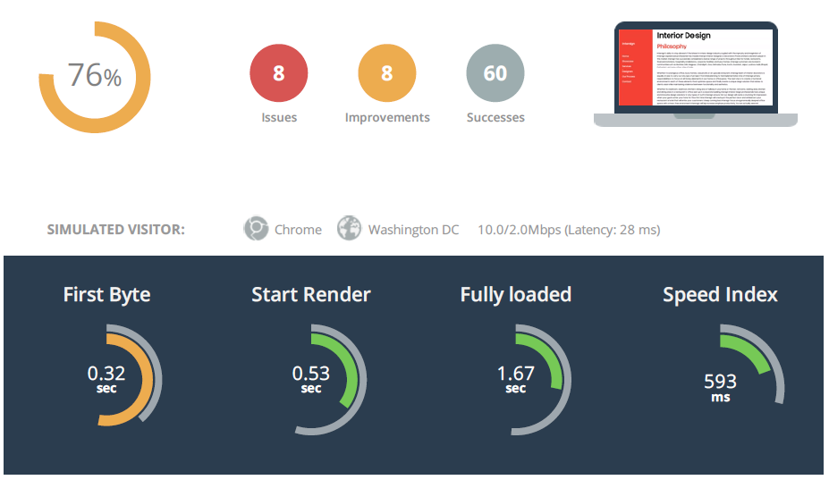

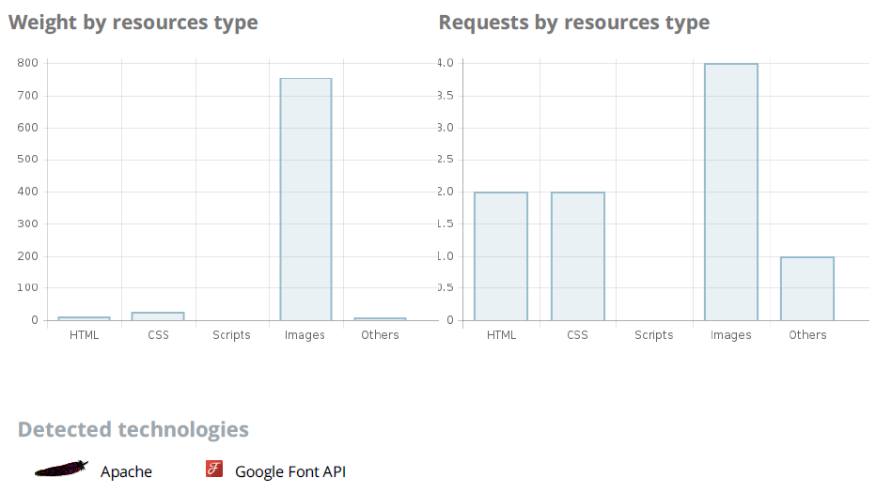

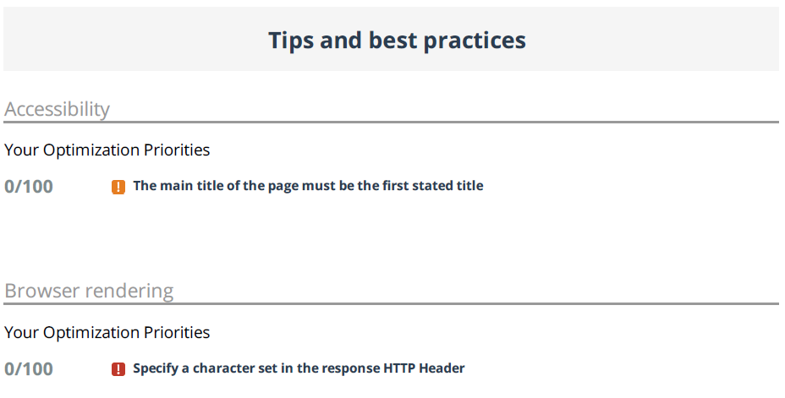

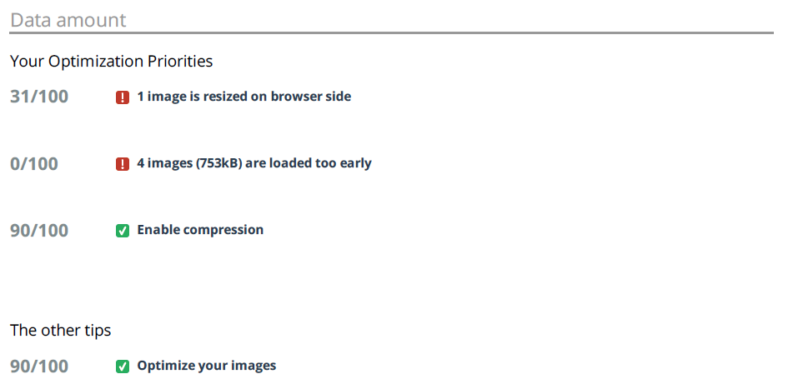

**5) CheckMyColour :**

It is a tool for checking background and foreground colour combinations of all DOM elements and determining if they provide sufficient contrast when viewed by someone having colour deficits.

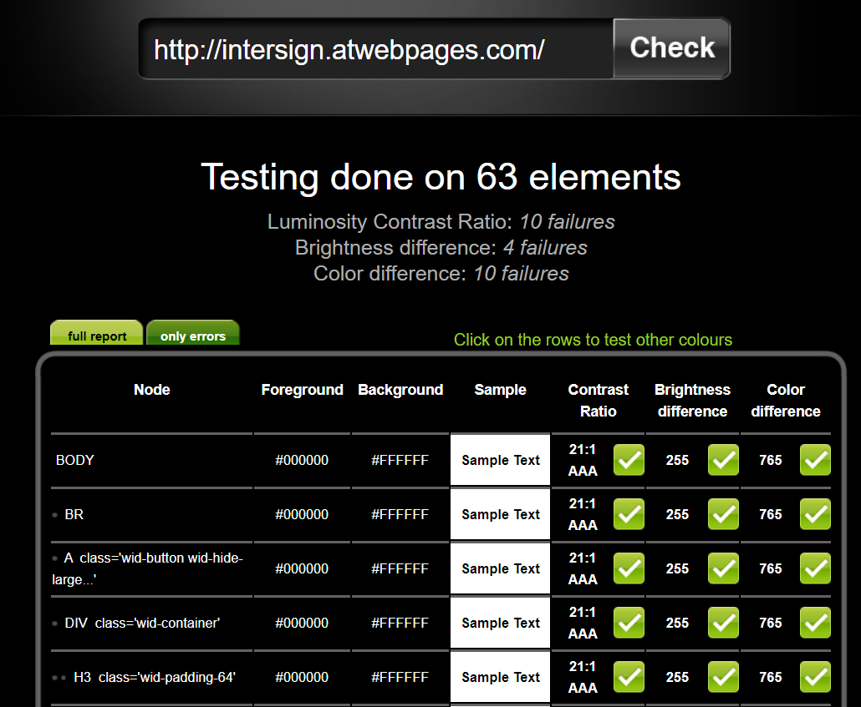

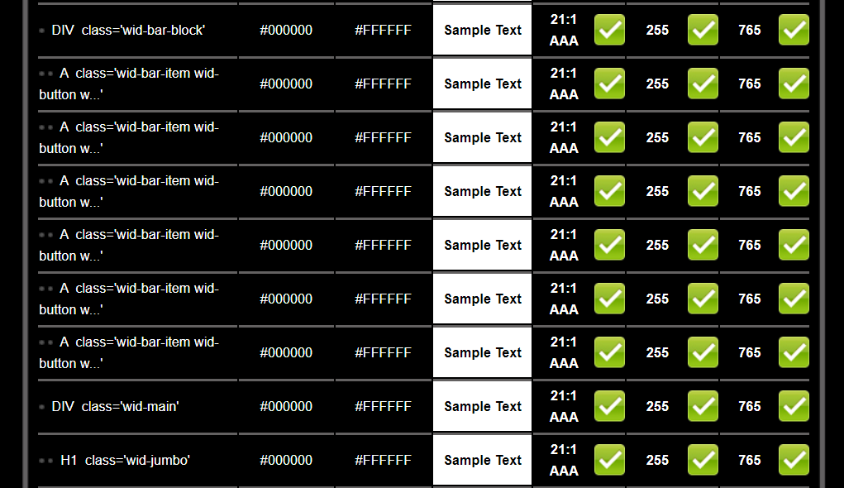

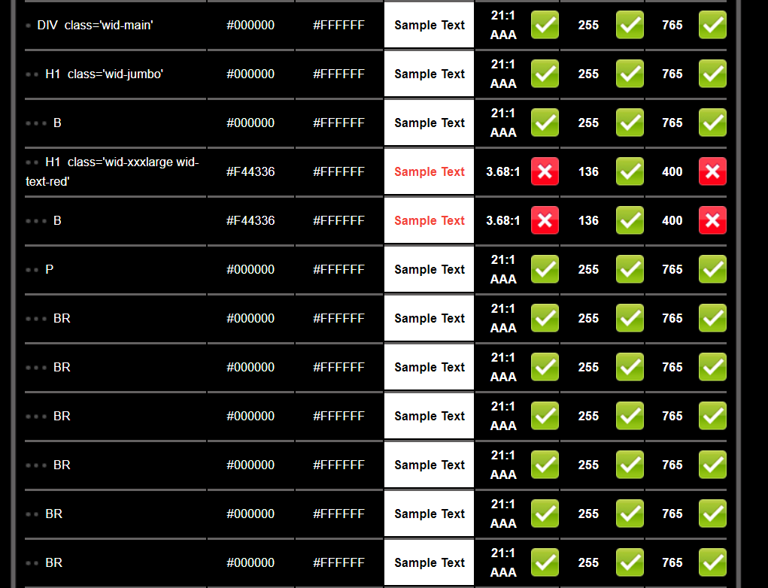

**6) Sitechecker :**

Sitechecker.pro is toolset for technical SEO analysis. It consists of three tools inside:

1. On Page SEO Checker;
2. Website Crawler;
3. Website Monitoring Tool.

On Page SEO Checker helps to analyze the specific URL in a real-time, get a full technical On Page Audit and fix collected errors due to recommendations. Website Crawler helps to crawl the whole website and get a full Website Audit that consists tips how to improve the website's technical health. Website Monitoring Tool helps to get notifications about changes in status codes, titles, h1, descriptions and indexing of the pages.

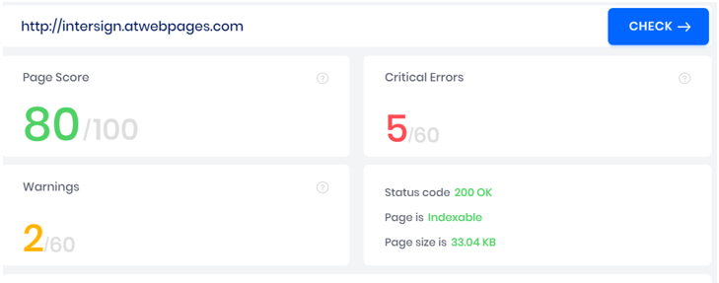

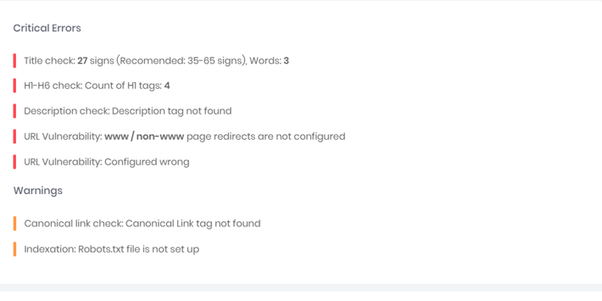

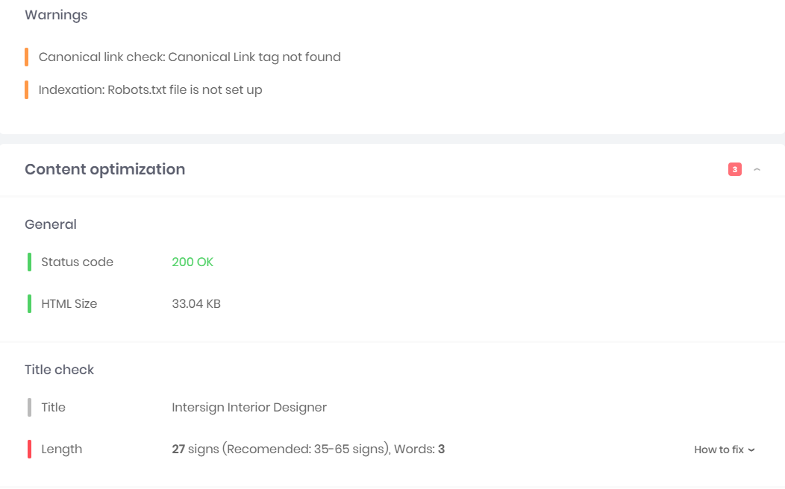



**Questions:**

1. Is automation always advantageous? When should one decide to automate test cases?

# ****Ans.)****

# ****Not always but when to use Automation testing is explained below,****

Consider a scenario where the defect is fixed in the build and similar feature was used in different working modules. So it is hard to check new bug is introduced in previous working functionality. While doing test pass you need to check regression testing around the defect fixes. This testing exercise needs to be executed each and every time you need to manually test the functionality around the impacted area. So considering resources, time and money you need to work effectively and smartly. In such scenarios you need to think of Automation testing.

Test automation is a process to check the software application after development and getting new build or release. The investment for test automation is time, money and resources. In requires initial efforts which will help you whenever you want to execute the regression cases/.

# ****Why to use Automation testing?****

Test can be automated due to many reasons. Some are,

# 1) Automation testing Saves Time and Money:

After each development of the Software product the test has to be repeated to ensure quality of the software. Due to every changes of source code the test has to be repeated. When the new software releases, we test that software is compatible to all operation system and also the hardware configurations. Manually testing same test suite repetitively is more costly and time consuming task. But, when we go for automation testing; only the initial cost is there after that it runs over and over again at no additional cost. One more advantage is it can be executed n number of times and they are much faster than manual tests. Automated software testing process reduces the time when test repetition starts, if manual testing is taking a day, automation will only take some hours.

# 2) Testing Increases Correctness:

In case of manual testing, the expert tester can do mistake due to each and every time changes of the test methodology, but in case of automation testing the same steps of test repeats each and every time when the source code changes which maintain the accuracy of a software system.

# 3) Automate the test due to version changes:

You can automate the test as many as possible, there is no boundary and time limit because developer can any time change the application code and introduces the bug.

Suppose, developer has change the application code and the new version of application has come up with some new features and bug fixes. So, how to make sure that the new bug fixes of new version have not introduced any new bug in previous working functionality? For that, you need to test the previous application too.

Is it possible to test the application manually whenever the application gets update? Yes it is possible, but will take longer time during test or some time it is not possible. Also, it won’t be effective in terms of company cost, resources, Time etc.

The best way to automate the test as many as the application version gets change and you get lots of regression work. So, to keep the application bug free, tester needs to test the application frequently. Completion of test automation process is totally depends on application whether; it is small, big or how many bugs are introduced in the application.

# 4) Increase Test Coverage:

Automated software testing more focus on the depth and scope of tests which increases the quality of software. Automated software testing process works on thousands of different complex test cases which is not possible with manual testing. If the software is huge and complex, manual testers are scare to test that software but testers who do automation testing can easily work on that particular software, automation testing also facilitates testers to test the software on multiple computers with different configurations. This testing process is capable to check the application inner database, data table, memory, and file containing the application to determine the application is performing as estimated.

# 5) Increases Speed, Efficiency, Quality and Decreases the Cost:

When we start developing the software, our main goal is to release the software on time. Although, Automation testing process uses same module in different test scenario, run fast. Automated regression test provides the non-stop system steadiness and functionality after changes to the software were completed main to shorter development cycles joint with better quality software and thus the welfare’s of automated testing fast out gain the initial costs.

# 6) Testers get Motivated which increases the efficiency:

In case on manual testing, testers do not get any new technique and tools, they apply manual tricks to test the software, that’s why they don’t get motivation which affects the manual tester’s efficiency. But, in case of automation testing, testers always get different tools with testing software which makes them to work fast with increasing efficiency.

# 7) Helpful in testing complex web application:

Automation testing process is helpful for those web applications where millions of users interact together. If we go for manual testing process, creating those many users manually and simultaneously are difficult or impossible.

So, to test those web applications go for load automation testing and create virtual users to check load capacity of the web application.

Automation testing process can also be used on that software where GUI will always be same and functionalities gets changed always due to source code changes.

**___________________________________________________________________________**

**Outcomes:**

Identify the needs of software test automation and its use in testing tool.

**_________________________________________________________________________**

**Conclusion: (Conclusion to be based on outcomes)**

In this experiment, we first developed a web application to apply various testing types on it. In software testing, test automation is the use of special software (separate from the software being tested) to control the execution of tests and the comparison of actual outcomes with predicted outcomes. We performed website speed testing (dotcom), webpage performance testing (GTmetrix), HTML/CSS validation testing (w3c validation), UI testing (checkMyColour). Report analysis from all tools are attached above.

**___________________________________________________________________________**

**Grade: AA / AB / BB / BC / CC / CD /DD**

**Signature of faculty in-charge with date**

**___________________________________________________________________________**

**References:**

**Books/ Journals/ Websites:**

1. Effective Methods for Software Testing , Third edition by Willam E. Perry, Wiley Publication
2. http://www.softwaretestinghelp.com/most-popular-web-application-testing-tools/
3. http://www.softwaretestinghelp.com/best-mobile-testing-tools/
4. http://www.seleniumhq.org/